A2609-MEX-Mixtec-Mask-Tlaloc-Rain God-Vesicular Andesite-Pre-classic-1350 CE

 

Figs. 1-2. MEX-Mixtec-Mask-Tlaloc-Rain God-Vesicular Andesite-Pre-classic-1350 CE

Formal Label: MEX-Mixtec-Mask-Tlaloc-Rain God-Vesicular Andesite-Pre-classic-1350 CE

Display Description:

This mask, carved from vesicular andesite, depicts the rain god Tlaloc of the Toltec; known as Tzahui, to the Mixtecs” (Nicholson 1967: 98) with characteristic ringed eyes, a prominent mouth­­­, an upper lip-moustache and a nose bar in the nasal septum.

|  |  |
| --- | --- |
| The Mixtecs or Mixtecos, are indigenous Mesoamerican peoples of Mexico inhabiting the region known as La Mixteca of Oaxaca and Puebla as well as the state of Guerrero's Región Montañas, and Región Costa Chica, which covers parts of the Mexican states of Oaxaca, Guerrero and Puebla.  The Mixtec region and the Mixtec peoples are traditionally divided into three groups, two based on their original economic caste and one based on the region they settled. High Mixtecs or mixteco alto were of the upper class and generally richer; the Low Mixtecs or "mixteco bajo" were generally poorer. In recent times, an economic reversal or equalizing has been seen. The third group is Coastal Mixtecs "mixteco de la costa" whose language is closely related to that of the Low Mixtecs; they currently inhabit the Pacific slope of Oaxaca and Guerrero. The Mixtec languages form a major branch of the Otomanguean language family.  In pre-Columbian times, a number of Mixtecan city states competed with each other and with the Zapotec kingdoms. The major Mixtec polity was Tututepec which rose to prominence in the 11th century under the leadership of Eight Deer Jaguar Claw, the only Mixtec king who ever united the Highland and Lowland polities into a single state. Like the rest of the indigenous peoples of Mexico, the Mixtec were conquered by the Spanish invaders and their indigenous allies in the 16th century. Pre-Columbia Mixtecs numbered around 1.5 million.[[4]](https://en.wikipedia.org/wiki/Mixtec#cite_note-4) |  |

LC Classification: Date or Time Horizon: 1350 CE

Geographical Area:

Map:

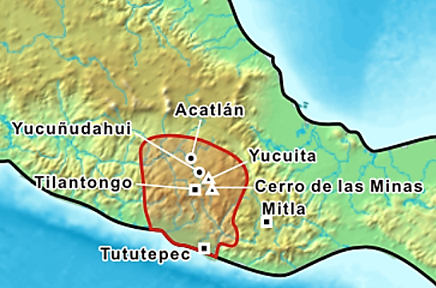

Mixtec area in Mexico. Map showing the historic Mixtec area. Pre-Classic archaeological sites are marked with a triangle, Classic sites with a round dot and Post-classic sites with a square. After https://upload.wikimedia.org/wikipedia/commons/thumb/0/0f/Mixtecs.png/450px-Mixtecs.png

GPS coordinates:

Cultural Affiliation: Mixtec

Medium: vesicular andesite

Dimensions: W 107.23 mm, 4.22 in; H 131.75 mm, 5.19 in

Weight: 739 gm, 1 lb, 10 oz

Condition: original

Provenance: Balam.

Discussion:

References:

Museum of Primitive Art. 1965. Masterpieces in the Museum of Primitive Art: Africa, Oceania, North America, Mexico, Central to South America, Peru. Handbook series. New York, NY: Museum of Primitive Art, no. 100.  
  
The Metropolitan Museum of Art. 1969. Art of Oceania, Africa, and the Americas from the Museum of Primitive Art. New York: The Metropolitan Museum of Art, no. 597.  
  
Newton, Douglas. 1978. Masterpieces of Primitive Art: The Nelson A. Rockefeller Collection. New York: Alfred A. Knopf.

Nicholson, I. 1967. Mexican and Central American Mythology. London: The Hamyln Publishing Group

Appendix:

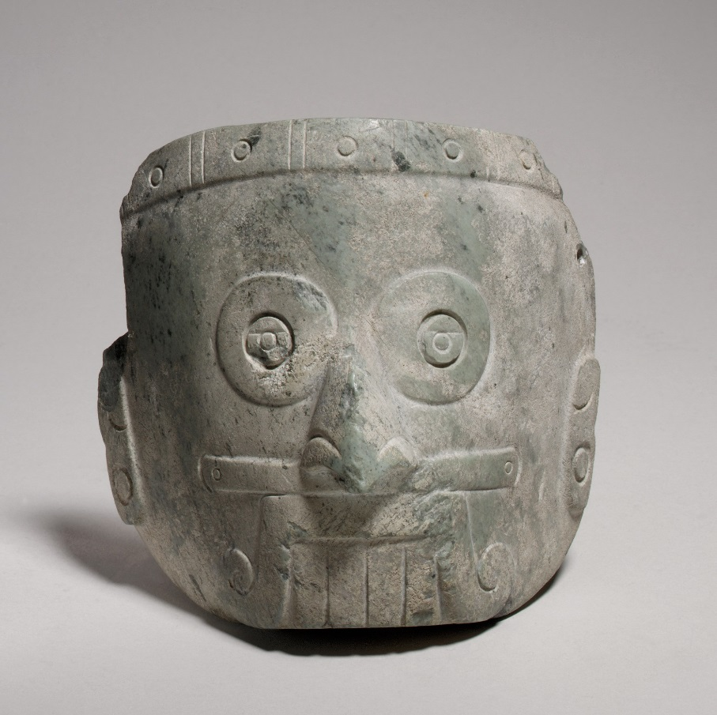

H. 5 1/2 x W. 6 x D. 3 in. (14 x 15.2 x 7.6 cm)

MET 1979.206.1062

***https://collectionapi.metmuseum.org/api/collection/v1/iiif/313255/662019/main-image***